David L. Suddjian
Biological Consulting Services

801 Monterey Avenue, Capitola, CA 95010
Telephone 831· 479· 9603, email dsuddjian@aol.com

Summary of 2008
Corvid Monitoring Surveys

In The Santa Cruz Mountains

Prepared for

Command Oil Spill Trustee Council

Prepared by

David L. Suddjian
Biological Consulting Services
801 Monterey Ave., Capitola, CA 95010

May 8, 2009

ABSTRACT

Monitoring of corvid populations at campgrounds and control areas continued in the Santa Cruz Mountains in 2008 at Big Basin Redwoods, Portola Redwoods, and Butano State Parks, and at San Mateo County Memorial Park. Numbers of Steller’s Jays declined over the six year period of study, with significant trends for all parks combined, and for each individual park. Changes were most pronounced in campgrounds, and were primarily due to declining numbers of adults, with no trend for numbers of juveniles. The decrease in adult jays may be due to recently implemented management actions, mortality from West Nile Virus, or both. A lack of a corresponding decrease in juveniles may reflect the concentrating effect of the campgrounds, or immigration of young birds from areas outside the park unaffected by management. Negative trends for jays and very low numbers at some campgrounds suggest that improved garbage management and user education have had positive benefits. In contrast to the jay, Common Raven numbers showed no significant trends for 2003-2008. However, ravens decreased in 2008, with some of the decrease likely due to lethal removal of individuals. American Crows were recorded at Big Basin and Memorial Parks during the spring and summer for the first time in 2008, although they did not reside through the nesting season in either park. Continued efforts at park user education and improved garbage receptacles have reduced the amount of human foods available to corvids since the study began. However, ongoing problems in garbage management are identified.

INTRODUCTION

In 2002 David Suddjian (unpubl. data) conducted a pilot study in Big Basin Redwoods State Park, Portola Redwoods State Park, Butano State Park, and San Mateo County Memorial Park (Figure 1) to compare relative abundance of corvids in areas of high human use with those well removed from areas of high use. In 2003 the Command Oil Spill Trustee Council (COSTC) initiated a corvid monitoring program in the same four parks that was patterned closely the 2002 effort (Suddjian 2004). The COSTC study was to assist the Council in restoration planning for potential projects benefiting the Marbled Murrelet (Brachyramphus marmoratus), including corvid management. This report presents the results of corvid monitoring surveys conducted in 2008.

Corvids are among the most significant predators on eggs and chicks of marbled murrelets (Nelson 1997, Peery et al. 2004). Both Steller’s Jay (Cyanocitta stelleri) and Common Raven (Corvus corax) have been documented to prey on murrelet eggs or chicks in the Santa Cruz Mountains (Singer et al. 1991, Suddjian 2003, 2003b, Perry et al. 2004), and Peery et al. (2004) demonstrated rates of nest predation as high as 61-87% in the region.

The Steller’s Jay has apparently always been a prominent member of the avian community in old growth forests of the Santa Cruz Mountains. In contrast, Common Ravens are relatively new in those forests, and have only become numerous since the 1980s (Figures 2 and3; Kelly et al. 2002, Bousman 2007). Both species are attracted to campgrounds and other areas of parks with high human use, where human food is often readily available. Consequently, previous studies and general observations in the Santa Cruz Mountains have typically found both Steller’s Jay and Common Raven to be much more numerous at campgrounds than away from campgrounds.

A third species of corvid, American Crow (C. brachyrhynchos), had been recorded only once prior to 2008 in the areas encompassed by this study. In 2008 it was found several times in the interior region of Big Basin, and at Memorial Park. These occurrences are described herein. Crows have not occurred at Butano or Portola as of 2008.

This study compares corvid populations in murrelet nesting habitat within campgrounds (treatment areas) to corvid populations in such habitat in areas located >300 meters from campgrounds (control areas). It also provides a baseline from which to judge future changes in numbers related to corvid management projects in the parks. Such projects were initiated in 2005.

Methods

Study Design

The 2002 pilot study sampled corvids in nine treatment areas and 19 control areas within the four parks and on adjacent private forest land (D. Suddjian unpubl. data). The monitoring program initiated by COSTC in 2003 established and surveyed one or more treatment and control areas in each park in 2003, except at Memorial, where no suitable control areas were identified (Table 1, and Figures 3 to 6). All of the treatment and control areas selected for the COSTC study overlapped entirely or partially with areas surveyed by Suddjian in 2002. Surveys from 2003 to 2008 sampled seven treatment areas and 12 control areas. All survey areas are in coast redwood (Sequoia sempervirens) forest known to support use by Marbled Murrelets, with nesting known or suspected to occur either in or immediately adjacent to each survey area. They range in size from 3.2 to 15.7 hectares (Table 1). Trees with potentially suitable nest platforms (Pacific Seabird Group 2003) were counted in each survey area to provide a measure of the structural habitat quality of each site for murrelets (Table 2).

Control areas are located a minimum of 300 meters from any campground, picnic area, or residential community, and are located along roads or trails to facilitate access. Treatment areas include standard campgrounds and their immediate surroundings. Group campgrounds were excluded because they were irregularly occupied, and they were often smaller than a minimum size criterion of 3.0 hectares (Suddjian 2004).

Management projects were initiated in 2005 in the three state parks to attempt to reduce corvid populations. These include lethal removal of ravens, increased emphasis on proper food storage, improvements in garbage receptacles and management, increased education for park users about Marbled Murrelets and about corvids as predators, and warnings and potential citations for campers feeding wildlife or improperly storing food or trash.

Description of Survey Areas

General Patterns Of Human Use

The campgrounds are used continuously throughout the survey period of June to August, although occupancy varies daily and through the season. Occupancy is typically at or near 100% on weekends, but often considerably less on weekdays, and is greater in July and August than in June. Campground occupancy during the surveys in 2008 ranged from 15% to 90% (Table 3). Overall occupancy for all sites combined was up 4% in 2008. All four campgrounds in Big Basin have exhibited a curvilinear trend in occupancy over the six year period, decreasing to an ebb in 2005-2006, and then increasing. Portola showed a non-significant decline in occupancy. Campgrounds at Butano and Memorial showed significant declines in occupancy (r² = 0.555, p = 0.05 and r² = 0.529, p = 0.05, respectively.

Human foods are continually available to corvids in varying degrees at occupied campgrounds. Food is occasionally (but regularly) offered directly to wildlife by campers, but is also widely available as discarded or fallen scraps or fragments, garbage left at camp sites, dog food left in the open, food fragments stuck on grills at fire rings, and at water spigots where dishes are rinsed. Food left unattended during the day or improperly stored at night is commonly plundered by wildlife. Additionally, in some parks food is readily available at trash receptacles that permit animal access, spillage by animals, are left open, or are too full to close properly. Another human-related food source, although more rarely available than human food, was road killed mammals, such as squirrels, raccoons and skunks on campground roads or other park roads.

Human activity in the control areas is mostly limited to hiking, bike riding and jogging, with no established picnic sites. Although each control area receives daily use by people in June to August, no one other than the surveyor were evident during any of the morning surveys in control areas in 2003 to 2008, with the exception of one park maintenance vehicle that drove through once at one site in 2005, and one jogger at one site in 2006.

Big Basin Redwoods State Park

Treatment areas are Blooms Creek Campground (55 sites), Sempervirens Campground (31 sites), Huckleberry Campground (71 sites), and Wastahi Campground (27 sites) (Table 1, Figure 4). Two control areas are located along the upper reach of Opal Creek, and four are along Gazos Creek Escape Road west of Opal Creek (Table 1, Figure 4).

There were no changes in garbage receptacles at Big Basin in 2008, except that some open metal trash cans (no lids) were added in the upper part of Blooms Creek Campground. The new (as of 2007) metal trash dumpsters with heavy lids were usually closed, but rarely were left open. Occasionally the lid of an overly full dumpster could not be closed, permitting birds and other animals to reach its contents.

Portola Redwoods State Park

The treatment area is the main campground, referred to here as Portola Campground (53 sites; Table 1, Figure 5). The control areas are along Peters Creek and a tributary north of the campground, and in two areas along the Iverson Trail (Table 1, Figure 5).

There were no changes in garbage receptacles at Portola in 2008. The campgrounds and picnic areas at Portola have metal trash receptacles with animal proof lids. No spillage was observed around the garbage receptacles in Portola in 2008.

Butano State Park

The treatment area is the Ben Ries Campground (38 sites; Table 1, Figure 6). The control areas are along the Butano Service Road extending northeast from the campground, Goat Hill Trial, and Doe Ridge Trail (Table 1, Figure 6).

There were no changes in garbage receptacles at Butano in 2008. Ben Ries Campground has animal-proof metal trashcans. No animal access or spillage was observed in 2008.

San Mateo Memorial County Park

The treatment area is the Sequoia Flat Campground (104 sites) (Table 1, Figure 7). No control areas with suitable habitat and sufficient distance from areas of high human use were identified, so control areas for this park were located in Big Basin instead (four areas along Gazos Creek Escape Road, Figure 4).

There were no changes in garbage receptacles at Butano in 2008. The smaller-size dumpsters were often observed to have their lids left open, mostly due to raccoons flipping the lids open during the night. Multiple dumpsters with opened lids were observed on every survey in 2008.

CoRvid Survey Methods

Each site was surveyed using the total area search method (Ralph et al. 1993). The search area at treatment areas included the entire area of campsites and extended outward 50 meters from the edge of the camp boundary. Control areas were established along roads and trails, and the search area extended outward for 50 meters from the center of the road or trail. Thus, the control areas were equivalent to 100-meter wide strip transects in which the total area searches were conducted. Fifty meters was selected as the outside distance to insure the best chance of visual detection of perched, silent birds. Vegetation obscured views too significantly beyond 50 meters. Movement off the road or trail was avoided in control areas to minimize noise made by the surveyor.

David Suddjian conducted all the surveys. Surveys were done by walking slowly through the survey site and pausing often for brief periods, listening for vocalizations and making visual scans to detect corvids. Although Luginbuhl et al. (2001) found that broadcasting taped calls enhanced detections of ravens, this method was not used in this study to avoid disturbance of campers and distraction to the surveyor when campers would inquire about the broadcast calls. Furthermore, the taped calls might attract ravens into the survey areas from outside the boundary during the survey.

Each jay and raven was recorded, indicating its age if known. Aging of ravens was straightforward through the season due to the status of molt of adults, feather wear, vocalizations, and the presence of a pale gape on the juveniles. Aging of jays was easy in June and most of July (using plumage pattern, begging behavior and vocalizations, and the pale gape of the juveniles), but it became more difficult in late July and August, when the juveniles more closely resembled adults and begging activity declined. Aging silent jays was sometimes difficult due to poor lighting conditions. Behavior of jays and ravens was recorded in notes, particularly as it related to foraging.

Other information recorded for each survey included date, start and end times, weather conditions, number of occupied campsites, number of opportunities to access human food (i.e., spilled trash, unattended food, campers feeding wildlife), and details of foods consumed by corvids.

Survey Frequency and Timing

Four surveys were conducted at each site, with one survey in June, two in July, and one in August. Survey dates in 2008 for each site are given on Table 4. Each site was surveyed only once per day (or if surveyed more than once per day, then data from the first survey of the day was used for analyses here), but usually more than one site was surveyed on the same morning. Campgrounds were only surveyed on weekdays. An effort was made to sample each site on dates close to those when it was sampled in prior years.

Each survey occurred in a window beginning 35 minutes after sunrise and extending for up to four hours after sunrise. The rationale for selection of this window of time for the surveys was described in Suddjian (2004). The time required to cover each survey area varied with the size of the area, but the average rate of coverage was 3.1 minute per ha (± 0.6 minute). The time expended in each area was kept fairly consistent over each of the four replications, and each year.

Analyses

Analyses comparing abundance in treatment and control areas used only the maximum number of corvids detected on any of the four surveys of each area (Luginbuhl et al. 2001), although average counts are also presented in the tables. Both adult and juvenile corvids were lumped for analyses of overall abundance. Numbers of adult and juvenile jays were analyzed to evaluate changes in abundance of each age class over time. Adjusted counts of adults and juvenile jays were derived from the raw counts using the percentage of juveniles observed during each survey replication in each park. Values of p < 0.05 were considered statistically significant, while values 0.1> p > 0.5 were considered marginally significant.

Some comparisons are made to the results of the preliminary study of 2002 (D. Suddjian unpubl. data) for all sites pooled together, as the sites were either the same as those of the COSTC-sponsored surveys, or overlapped with them broadly, and the surveys methods were the same.

Results

Steller’s Jay

Survey results and statistical comparisons for each park in 2008 are given on Tables 5 and 6. Raw counts of jays for 2003 to 2008 are given in Appendix 1. Adjusted counts of adult and juvenile jays are given in Appendix 2. Steller’s Jays were recorded at all survey sites. Steller’s Jays were recorded on all but one survey in treatment areas (96%), and on 92% of 48 surveys in control areas (Table 5). They were ubiquitous in treatment areas, where overall they were 6.2 times more numerous than in control areas, with the difference being highly significant (Table 6). The higher numbers in treatment areas compared to controls was significant for each park except Butano, where low numbers of jays at Ben Ries Campground were actually less than in that park’s control areas (Table 5, Appendix 1).

Overall, jay abundance (all parks combined) was the same in 2008 as in 2007, but those two years had fewer jays than 2003-2006 (Table 9, Figure 8). There was a significant negative trend for treatment areas from 2003 to 2008 (r² = 0.752, p = 0.006), with jay abundance decreasing by 54% over the 6-year period. A negative trend for control areas (r² = 0.537) was also significant (p = 0.030), with jay abundance decreasing by 29% over the 6-year period. The ratio of jays in treatment and control areas decreased from 9.7:1 in 2003 to 6.2:1 in 2008, with a significant trend (r² = 0.920, p = 0.001). Changes in absolute numbers in control areas were small.

Among individual parks, the 6-year trend in total jay abundance showed significant declines in treatment areas at Portola (r² = 0.750, p = 0.012), Butano (r² = 0.867, p = 0.003) and Memorial (r² = 0.717, p = 0.017), and a marginally significant decline at Big Basin (r² = 0.455, p = 0.071) (Figure 9). There were no significant trends in jay numbers in control areas in individual parks (Figure 9).

Jays remained most abundant at Memorial in 2008, where they were three to 12 times more numerous than at the other parks; Butano had dramatically fewer jays per hectare than the other parks (Figure 10). The maximum raw count for any area in 2008 was 98 jays at Sequoia Flat Campground at Memorial on August 25, 2008.

The percentage of juvenile jays in the overall study area has consistently exhibited an increase across the survey season; the percentage has increased geometrically in treatment areas, but with relatively small increases in control areas (Figure 11). This apparently reflects a movement of jays into the campgrounds from outlying areas, perhaps from long distances. Substantial numbers of juvenile jays congregate in some campgrounds (notably Sequoia Flat, Blooms Creek and Huckleberry). An increase in adult jays in treatment areas from June to late July (coincident with a decrease in numbers in control areas) suggests a similar movement may occur for adults, but to a lesser degree (Figure 12).

The annual maxima for adult jays in treatment areas in all parks combined exhibited a highly significant decline over the six-year period, with numbers in 2008 being the lowest for this study (r² = 0.916, p = 0.001; Figure 13a). However, adults in control areas showed a non-significant declining trend (Figure 13b). There were no trends in the numbers of juveniles jays in either treatment or control areas (all parks combined) over the six year period.

Adult jays exhibited significant declines at all four individual parks: Big Basin (r² = 0.715, p = 0.013, Portola (r² = 0.549, p = 0.046), Butano (r² = 0.958, p < 0.001, and Memorial (r² = 0.811, p = 0.007 (Figure 14). The same pattern of decline in adults was evident when six-year trend analyses were limited just to the results of the June surveys, the period which more closely reflects the population of jays actually nesting in the treatment areas. Significant declines in June were evident at Big Basin, Butano and Memorial, and all parks combined, but not Portola (Figure 15). A significant decline in adults in control areas was observed at Butano (r² = 0.827, p = 0.006), with a marginally significant decline in adults in control areas at all parks combined (r² = 0.401, p = 0.088).
In contrast to trends for adult jays, the six-year trend for juvenile jays was not significant in either treatment or control areas (Figures 13 and 14).

Absolute numbers of adult and juvenile jays were far greater at Big Basin and Memorial, than at Portola and Butano (Figure 16), reflecting the much larger campground areas in the former two parks.

Jay behavior and interactions with people were similar to those observed in previous years (Suddjian 2004 et. seq.). Jays were frequently seen inspecting occupied campsites for food, and were quick to capitalize on opportunities to steal unattended food, or to search for food in just-vacated sites. Jays were observed taking advantage of spilled garbage, stealing unattended food in camps, being fed directly by campers, and picking food fragments from campfire grills and at water spigots. Human foods taken by jays during the surveys were similar to those mentioned in Suddjian (2004).

Jays typically began each morning with an active search of campsites for food scraps left from the previous night, and visited trash receptacles where nocturnal mammals had made food available (primarily at Memorial Park). Places where jays consistently sought and found scraps of food were at the campsite tables, grills of campsite fire rings, and at campground water spigots where campers rinse their dishes. Some individuals spent considerable time foraging by digging into the dirt and duff at campsites and consuming small items of undetermined identity. Natural foods frequently taken by jays in campgrounds included huckleberries and tanoak acorns. Young jays were especially attracted to ripening huckleberries.

Common Raven

Survey results and statistical comparisons for each park in 2008 are given on Tables 7 and 8. Raw counts for 2003 to 2008 are given in Appendix 1. Common ravens were recorded in all seven of the treatment areas in 2008, where they were detected on 68% of the 28 surveys; they were seldom noted at Wastahi and Ben Ries campgrounds in 2008 (Table 7). In contrast, they were detected at four (33%) of the 12 control areas, and detected on only 10% of 48 surveys (Table 7). Raven numbers in treatment areas exceeded those in control areas by 8.0 times when the data from all sites were pooled (Table 8). Ravens were significantly more numerous in treatment areas than control areas at all four parks (Table 8).

Common Ravens decreased in overall abundance (all parks combined) in both treatment and control areas from 2007 to 2008 (Figure 17). In individual parks they decreased in treatment areas at Big Basin, Butano and Memorial, and remained the same at Portola, and decreased in control areas in all parks (Figure 18). However, the changes in absolute numbers were small (Appendix 1).

There were no trends for 2003-2008 for all treatment areas combined or all control areas. Among individual parks, there were no significant trends for the six-year period for either treatment or control areas (Figure 18).

Ravens were generally uncommon, and no large groups were observed in 2008. Most surveys recorded only one or two adults, and more rarely three adults. As in most past years raven numbers did not increase consistently over the season among the sites (Table 7). Most treatment sites had one pair (occasionally two pair) of adults that was regularly or irregularly present, and in some cases their offspring. The only aggregation observed other than resident pairs or families was recorded during at Portola on July 28, when nine adults flew north near Slate Creek Trail Camp, well east of the Portola campground.

At Big Basin there were approximately seven pairs of ravens in the general region of the park containing the survey areas, plus a few additional single birds. This represented a decrease of at least 4 pairs from 2007. Productivity was moderate, with at least four pairs fledging two or three juveniles each, for a total off at least 10 juveniles (down from 22 in 2007). Family groups with fledglings (first evident on June 5) were at: Blooms Creek Campground, Huckleberry Campground, near Sempervirens Reservoir, at the south end of the day use picnic area (and ranging south to Redwood Trail).

At Portola one pair of ravens nested 0.25 miles south of park headquarters (and a similar distance from the main campground) in the same spot as in 2007, fledging two juveniles by July 9. However, by July 28-30 the adults were still present but the juveniles were not in evidence, so they probably did not survive. This was the only pair present in the area of the park covered by this study in 2008.

At Butano a pair of ravens continued to reside in the area of Ben Ries Campground and northwest of there, but they either did not nest or an attempt failed before fledging. Another pair was located southwest of Ben Ries Campground, in the lower part of the Little Butano canyon. The latter pair did not range into the area covered by surveys for this study. No juveniles were noted in Butano in 2008.

At Memorial three pairs of ravens nested in or near the park in 2008, with at least two of these pairs fledging a total of at least 4 juveniles. One pair likely nested north of Sequoia Flat Campground, with other pairs nesting near Wurr Flat Group Campground and near Homestead Flat Group Campground. A single juvenile was seen briefly on only one day at Sequoia Flat Campground, with not other evidence of young ravens there during the visits to the park. However, up to six adults at a time were observed at Sequoia Flat.

Raven behavior and interactions with people were similar to those described previously (Suddjian 2004 et seq.). As in prior years, they remained wary and did not approach people or take handouts. But they regularly investigated campsites when people were absent, visited spilled garbage, and stole unattended food. The concentration of naïve fledgling jays at campgrounds continued to attract attention from ravens, and seemed to be a principal attraction for them at campgrounds.

AMERICAN CROW

At Big Basin American Crows were noted from late February to early April, and again once in early August. There was no indication of any resident crows in the interior region of the park during the 2008 breeding season. Sightings of crows in early spring included: one flying west over park headquarters on February 27; two flying over the upper watershed of the north fork of Union Creek on March 3; two perched along China Grade near Tray’s Ranch on March 4; one flying over park headquarters on March 7; and one was in the vicinity of the upper junction of China Grade at Highway 236 on March 22 to April 11. In late summer one was along China Grade just south of the San Mateo County line on August 1. These are the only records for the interior region of Big Basin Redwoods State Park except for one that was shot at Huckleberry Campground on April 6, 2005.

At Memorial Park crows were seen at the west end of the park in May and at the east end of the park in July. A pair of crows was interacting with a pair of ravens at Homestead Group Campground on May 16, 2008. One crow was found dead along Pescadero Road near the park’s west boundary on May 30, possibly killed by a car. One crow was seen on the July 22 in the eastern part of the park. It was first heard calling near the Wurr Road bridge. It then moved to the Wurr Group Campground area, then north into the Tan Oak Flat Picnic Area. There were no records of American Crows in Memorial Park before 2008.

Discussion

Steller’s Jay continued its declining trend over the six year period of study, with significant trends for all parks combined, and for all four individual parks. Changes were most pronounced in treatment areas, and were primarily due to declining numbers of adults, with no trend for numbers of juveniles. The decrease in adult jays may be due to management actions promulgated by the COSTC. Some of the decrease might also be related to mortality from West Nile Virus. The lack of a corresponding decrease in juveniles may reflect the concentrating effect of the campgrounds, where they attract sufficient numbers of juvenile jays from outlying areas to mask changes in the number of young produced in the vicinity of the campgrounds. Or juveniles may be entering the parks from outside areas where breeding populations are not affected by management actions.

Very low numbers of jays were recorded at Ben Ries Campground in Butano for the second year in a row, with a peak count there in 2008 of just six jays. Jay numbers in that campground were on a par with those in control areas. Thus, campgrounds do not always support elevated numbers of jays. These low counts (in some cases even when the campground was mostly full of campers) suggest that improved garbage management and user education has had positive benefits.

In contrast to the jay, Common Raven showed no significant trends for the 2003-2008 period. However, ravens decreased in 2008, with fewer nesting pairs and relatively low success. Some of this decrease in numbers and productivity was likely due to shooting of ravens in 2008. However, a number of opportunities to remove nesting pairs and especially groups of fledglings were not used as effectively as they might have been.

The presence of American Crows in two of the parks in 2008 was likely related to expanding ranges and populations of this species in both San Mateo and Santa Cruz counties, and in particular to range expansions in the Boulder Creek watershed southeast of Big Basin, and the Pescadero area west of Memorial. Multiple detections in 2008 suggest that crows may soon become a part of the suite of Marbled Murrelet predators in the Santa Cruz Mountains region.

Continued efforts at park user education and improved garbage receptacles have reduced the amount of human foods available to corvids since the study began. However, ongoing problems in garbage management continued at Big Basin in 2008, when dumpsters were sometimes overfull and open trashcans were installed at Blooms Creek Campground. The light weight plastic lids on some of the dumpsters at Memorial continued to permit access by raccoons and other animals that came after them.

Literature Cited

Bousman, W. G. 2007. Breeding Bird Atlas of Santa Clara County, California. Santa Clara Valley Audubon Society. 547 pp.

Kelly, J. P., K. L. Etienne and J. E. Roth. 2002. Abundance and distribution of the common raven and American crow in the San Francisco Bay Area, California. West. Birds 33:202-217.

Luginbuhl, J. M., J. M. Marzluff, J. E. Bradley, M. G. Raphael, and D. E. Varland. 2001. Corvid survey techniques and the relationship between corvid relative abundance and nest predation. Journal of Field Ornithology 72:556-572.

Nelson, S. K. 1997. Marbled Murrelet (Brachyramphus marmoratus). No. 276 in The birds of North America (A. Poole and F. Gill, Eds.) Acad. Of Nat. Sci., Philadelphia, Pennsylvania, and the Amer. Orn. Union, Washington D.C.

Pacific Seabird Group. 2003. Methods for surveying Marbled Murrelets in forests: a revised protocol for land management and research. Marbled Murrelet Technical Committee. Unpubl. report dated 6 January, 2003.

Peery, M. Z, S. R. Beissinger, S. H. Newman, E. B. Burkett, and T. D. Williams. 2004.
Applying the declining population paradigm: diagnosing causes of poor reproduction in
the marbled murrelet. Conservation Biology 18:1088-1098.

Powell, H. 2005. The accidental reaper – ravens are following people into new habitats. California Wild. Summer 2005. California Academy of Sciences.

Ralph, C. J., Geupel, G. R., Pyle, P., Martin T. E. and D. F. DeSante. 1993. Handbook of field methods for monitoring landbirds. Gen. Tech. Rep. PSW-GTR-144. Pac. Southwest Res. Station, Forest Service, U.S.D.A.

Singer, S. W., Naslund, N. L., Singer, S. A., and C. J. Ralph. 1991. Discovery and observation of two tree nests of the Marbled Murrelet. Condor 93: 330-339.

Suddjian, D. L. 2003. Summary of 2002 Marbled Murrelet monitoring surveys
at Big Basin and Portola State Parks. Unpubl. report. Prepared for the California Dept. of Fish and Game.

Suddjian, D. L. 2004. Summary of 2003 corvid monitoring surveys in the Santa Cruz Mountains. Unpubl. report prepared for the Command Oil Spill Trustee Council.

Suddjian D. L. 2005a. Summary of 2004 corvid monitoring surveys in the Santa Cruz Mountains. Unpubl. report prepared for the Command Oil Spill Trustee Council.

Suddjian D. L. 2005b. Summary of 2005 corvid monitoring surveys in the Santa Cruz Mountains. Unpubl. report prepared for the Command Oil Spill Trustee Council.

Suddjian, D. L. 2008. Summary of 2006 corvid monitoring surveys in the Santa Cruz Mountains. Unpubl. report prepared for the Command Oil Spill Trustee Council.
Table 1. Attributes of the corvid survey areas.

Human Area Slope Approx. Canopy Composition³

Survey Area Type Use Access¹ (ha) Position² Elevation RW DF TO FLO MA Other

Big Basin Redwoods SP
Blooms Creek Treatment Camp 1 15.7 B 900–1,120’ 1 2 1 2 3 3
Sempervirens Treatment Camp 1 7.2 B 960-1,080’ 1 2 1 2 3 --
Huckleberry Treatment Camp 1,2 13.4 B 980-1,160’ 1 2 1 1 2 --
Wastahi Treatment Camp 1,3 7.2 B 1,020-1,250’ 1 2 1 -- -- --
Opal Creek 2 Control Hiking 1 10.2 B 1,050-1,180’ 1 2 1 3 3 3
Opal Creek 3 Control Hiking 3 6.6 B 1,075-1,225’ 1 2 1 3 3 3
Gazos Creek Road 1 Control Hiking 2 9.4 S 1,120-1,280’ 1 2 1 2 2 --
Gazos Creek Road 2 Control Hiking 2 6.7 S 1,240-1,350’ 1 1 1 2 2 --
Gazos Creek Road 3 Control Hiking 2 7.5 S 1,140-1,320’ 1 2 1 2 2 --
Gazos Creek Road 4 Control Hiking 2 7.5 S 960-1,180’ 1 2 1 2 2 --

Portola Redwoods SP
Portola Treatment Camp 1 8.4 B 350-560’ 1 2 1 1 3 3
Peters Creek Control Hiking 1,3 7.7 B 400-600’ 1 2 1 2 3 3
Iverson Trail 1 Control Hiking 3 7.1 B 320-520’ 1 2 1 2 2 3
Iverson Trail 2 Control Hiking 2,3 6.9 B 350-520’ 1 2 1 3 3 3

Continued on next page,

Table 1, continued

Human Area Slope Approx. Canopy Composition³

Survey Area Type Use Access¹ (ha) Position² Elevation RW DF TO FLO MA Other

Butano SP
Ben Ries Treatment Camp 1,3 9.6 B 400-650’ 1 2 1 3 3 --
Butano Service Road Control Hiking 2 8.1 B 500-670’ 1 2 1 3 3 3
Goat Hill Trail Control Hiking 3 3.2 S 620-840’ 1 2 1 2 3 --
Doe Ridge Trail Control Hiking 3 15.7 S 880-1,120’ 1 1 1 2 3 --

Memorial CP
Sequoia Flat Treatment Camp 1 12.6 B 180-280’ 1 2 1 2 -- 3

1. Access: 1 (paved road), 2 (unpaved road), 3 (trail).
2. Slope position: B (bottom of valley), S (mid-slope), R (ridgeline).
3. Approximate canopy cover by each tree species, classed as 1 (50-100%), 2 (11-49%), 3 (1-10%). Tree species: RW (coast redwood), DF (Douglas-fir), TO (tan oak), FLO (Forest (Shreve) live oak), MA (madrone), other (includes California bay, red alder, white alder, and big leaf maple)
Table 2. Number of trees with platforms in each survey area¹.

Area # # # # RW # DF # All

Survey Area (ha) RW² DF All / ha / ha / ha

Big Basin
Blooms 15.7 11 38 49 0.7 2.4 3.1
Sempervirens 7.2 7 16 23 1.0 2.2 3.2
Huckleberry 13.4 28 31 59 2.1 2.3 4.4
Wastahi 7.2 9 8 17 1.3 1.1 2.4
Opal 2 10.2 16 11 27 1.6 1.1 2.7
Opal 3 6.6 6 12 18 0.9 1.8 2.7
Gazos 1 9.4 11 13 24 1.2 1.4 2.6
Gazos 2 6.7 10 9 19 1.5 1.3 2.8
Gazos 3 7.5 13 3 16 1.7 0.4 2.1
Gazos 4 7.5 7 4 11 0.9 0.5 1.5

Portola
Portola 8.4 21 33 54 2.5 3.9 6.4
Peters 7.7 4 22 26 0.5 2.9 3.4
Iverson 1 7.1 16 29 45 2.3 4.1 6.4
Iverson 2 6.9 11 18 29 1.6 2.6 4.2

Butano
Ben Ries 9.6 17 44 61 1.8 4.6 6.4
Service 8.1 3 20 23 0.4 2.5 2.8
Goat Hill 3.2 2 8 10 0.6 2.5 3.1
Doe Ridge 15.7 9 25 34 0.6 1.6 2.2

Memorial
Sequoia 12.6 39 45 84 3.1 3.8 6.7

1. “Platforms” were features in the live crown of a conifer that offered potentially suitable nest sites for Marbled Murrelets; “a relatively flat surface at least 10 cm (4 in) in diameter and 10 m (33 ft) high” Pacific Seabird Group (2003, p. 2).

2. “RW” (coast redwood), “DF” (Douglas-fir).
Table 3. Campground occupancy (%) during the 2008 corvid surveys, and average occupancy from 2003-2008.

2008 2003-2008

Survey Area # of Run 1 Run 2 Run 3 Run 4 Avg occupancy
Sites 03 04 05 06 07 08

Big Basin
Blooms 55 65 78 85 80 75 67 53 61 73 77
Sempervirens 31 71 55 90 65 79 72 49 52 63 70
Huckleberry 71 48 41 62 65 66 52 36 42 52 54
Wastahi 27 15 41 37 30 43 30 18 22 46 31

Portola
Portola 53 25 36 25 21 44 24 20 22 20 26

Butano
Ben Ries 38 34 61 58 79 73 88 82 73 66 58

Memorial
Sequoia 104 38 36 47 38 53 43 44 29 29 39

All Areas 379 42 47 56 52 61 50 42 41 46 50
Combined
Table 4. Dates of the 2008 corvid surveys.

Survey Dates

Survey Area Run 1 Run2 Run 3 Run 4

Big Basin
Blooms Creek June 19 July 3 July 18 August 19
Sempervirens June 19 July 3 July 18 August 19
Huckleberry June 19 July 3 July 18 August 19
Wastahi June 19 July 3 July 18 August 19
Opal Creek 2 June 16 July 4 July 17 August 18
Opal Creek 3 June 16 July 4 July 17 August 18
Gazos Creek Road 1 June 18 July 6 July 19 August 18
Gazos Creek Road 2 June 18 July 6 July 19 August 18
Gazos Creek Road 3 June 18 July 6 July 19 August 18
Gazos Creek Road 4 June 18 July 6 July 19 August 18

Portola
Portola June 25 July 11 July 28 August 26
Peters Creek June 25 July 11 July 28 August 26
Iverson Trail 1 June 24 July 10 July 29 August 26
Iverson Trail 2 June 24 July 10 July 29 August 26

Butano
Ben Ries June 11 July 1 July 24 August 12
Butano Service Road June 12 July 2 July 25 August 12
Goat Hill Trail June 12 July 2 July 25 August 12
Doe Ridge Trail June 12 July 2 July 25 August 12

Memorial
Sequoia Flat June 13 July 14 July 22 August 25

Table 5. Number of Steller’s Jays per hectare on the 2008 surveys.

Survey Area Run 1 Run 2 Run 3 Run 4 Max Avg

Big Basin
Blooms 1.27 1.34 3.63 1.91 3.63 2.04
Sempervirens 0.83 1.11 2.92 3.19 3.19 2.01
Huckleberry 2.01 3.13 3.36 0.75 3.36 2.31
Wastahi 0.42 0.28 0.28 0.00 0.42 0.24
Opal 2 0.00 0.20 0.20 0.10 0.20 0.12
Opal 3 0.30 0.30 0.30 0.15 0.30 0.27
Gazos 1 0.21 0.21 0.22 0.11 0.21 0.19
Gazos 2 0.15 0.00 0.30 0.00 0.30 0.11
Gazos 3 0.27 0.53 0.53 0.27 0.53 0.40
Gazos 4 0.27 0.27 0.13 0.00 0.27 0.17

Portola
Portola 1.19 2.86 2.86 1.67 2.86 2.14
Peters 0.26 0.26 0.39 0.26 0.39 0.29
Iverson 1 0.42 0.28 0.42 0.28 0.42 0.35
Iverson 2 0.43 0.72 0.29 0.29 0.72 0.43

Butano
Ben Ries 0.42 0.42 0.52 0.63 0.63 0.49
Service 0.25 0.49 0.37 0.49 0.49 0.40
Goat Hill 0.31 2.19 0.30 0.31 2.19 0.78
Doe Ridge 0.13 0.32 0.13 0.06 0.32 0.16

Memorial
Sequoia 1.90 4.76 7.62 7.78 7.78 5.52

Table 6. Comparison of numbers of Steller’s Jays in treatment and control areas in 2008.

Statistical
Survey Area Avg/ha¹ S.E. N Significance

All parks combined
Treatment 3.1 2.44 7 P^{(1-tailed)} < 0.001
Control 0.5 0.57 12

Big Basin
Treatment 2.7 1.50 4 P^{(1-tailed)} < 0.002
Control 0.3 0.12 6

Portola
Treatment 2.9 0.00 1 P^{(1-tailed)} = 0.004
Control 0.5 0.18 3

Butano
Treatment 0.63 0.00 1 P^{(1-tailed)} = 0.393
Control 1.0 1.03 3

Memorial
Treatment 7.8 0.00 1 P^{(1-tailed)} < 0.001
Control² 0.3 0.14 4 ²see note

- Average of maximum counts from each survey area.
2. Controls for Memorial CP were located in Big Basin Redwoods SP.

Table 7. Number of Common Ravens per hectare on the 2008 surveys.

Survey Area Run 1 Run 2 Run 3 Run 4 Max Avg

Big Basin
Blooms 0.25 0.25 0.25 0.13 0.25 0.22
Sempervirens 0.00 0.14 0.14 0.14 0.14 0.10
Huckleberry 0.15 0.07 0.37 0.00 0.37 0.15
Wastahi 0.00 0.00 0.00 0.28 0.28 0.07
Opal 2 0.00 0.00 0.00 0.00 0.00 0.00
Opal 3 0.00 0.00 0.15 0.00 0.15 0.04
Gazos 1 0.11 0.00 0.00 0.11 0.11 0.05
Gazos 2 0.00 0.00 0.00 0.00 0.00 0.00
Gazos 3 0.00 0.00 0.13 0.00 0.13 0.03
Gazos 4 0.00 0.00 0.00 0.00 0.00 0.00

Portola
Portola 0.12 0.48 0.12 0.00 0.48 0.18
Peters 0.00 0.00 0.00 0.00 0.00 0.00
Iverson 1 0.14 0.00 0.00 0.00 0.14 0.04
Iverson 2 0.00 0.00 0.00 0.00 0.00 0.00

Butano
Ben Ries 0.00 0.00 0.00 0.21 0.21 0.05
Service 0.00 0.00 0.00 0.00 0.00 0.00
Goat Hill 0.00 0.00 0.00 0.00 0.00 0.00
Doe Ridge 0.00 0.00 0.00 0.00 0.00 0.00

Memorial
Sequoia 0.24 0.48 0.08 0.32 0.48 0.28

Table 8. Comparison of numbers of Common Ravens in treatment and control areas in 2008.

Statistical
Survey Area Avg/ha¹ S.E. N Significance

All parks combined
Treatment 0.32 0.13 7 p^{(1-tailed)} < 0.001
Control 0.04 0.07 12

Big Basin
Treatment 0.26 0.10 4 p^{(1-tailed)} = 0.003
Control 0.07 0.07 6

Portola
Treatment 0.48 0.00 1 p^{(1-tailed)} < 0.022
Control 0.05 0.08 3

Butano
Treatment 0.21 0.00 1 p^{(1-tailed)} < 0.001
Control 0.00 0.00 3

Memorial
Treatment 0.48 0.00 1 p^{(1-tailed)} < 0.001
Control² 0.06 0.07 4 ²see note

- Average of maximum counts from each survey area.
- Controls for Memorial CP were located in Big Basin Redwoods SP.

Table 9. Number of corvids per hectare in treatment and control areas in the four parks from 2002 to 2008.

Species 2002¹ 2003 2004 2005 2006 2007 2008

Steller’s Jay
Treatment areas 5.4 ± 1.5 6.8 ± 3.7 4.5±2.9 4.4±3.9 4.1±2.0 3.1±2.5 3.1±2.4
Control areas 0.6 ± 0.3 0.7 ± 0.3 0.5±0.3 0.5±0.4 0.5±0.4 0.4±0.2 0.5±0.6

Com. Raven
Treatment areas 0.6 ± 0.3 0.2 ± 0.2 0.4±0.3 0.3±0.2 0.2±0.1 0.4±0.2 0.3±0.1
Control Areas 0.1 ± 0.1 0.1 ± 0.1 0.1±0.1 0.1±0.04 0.1±0.1 0.1±0.2 0.4±0.1

- 2002 surveys (D. Suddjian unpublished data)

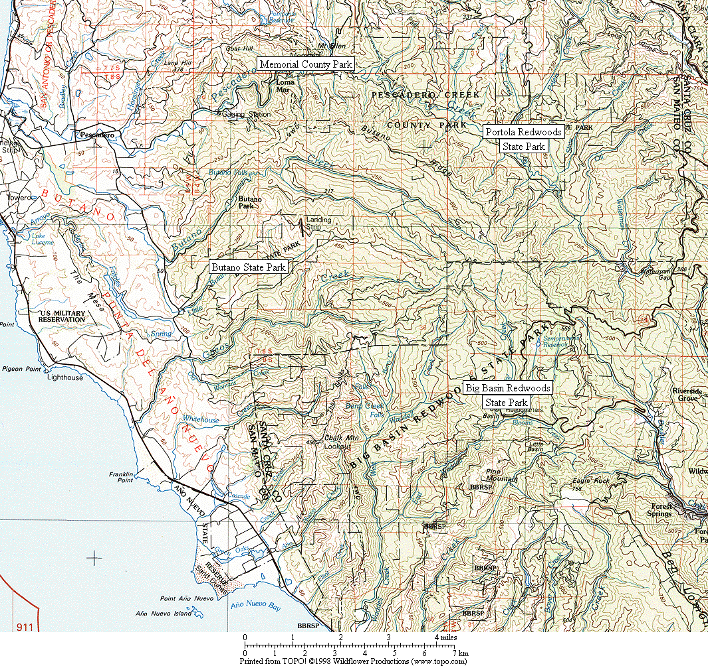

Figure 1. General location of survey areas.

Figure 2. Common Ravens have increased dramatically in all six Christmas Bird Count circles in the Santa Cruz Mountains region. (Note: data presented as a 3-year running mean.)

Figure 3. Increase in Common Raven as recorded by all six Santa Cruz Mountains region CBCs combined. (See Figure 2 for listing of individual counts.)
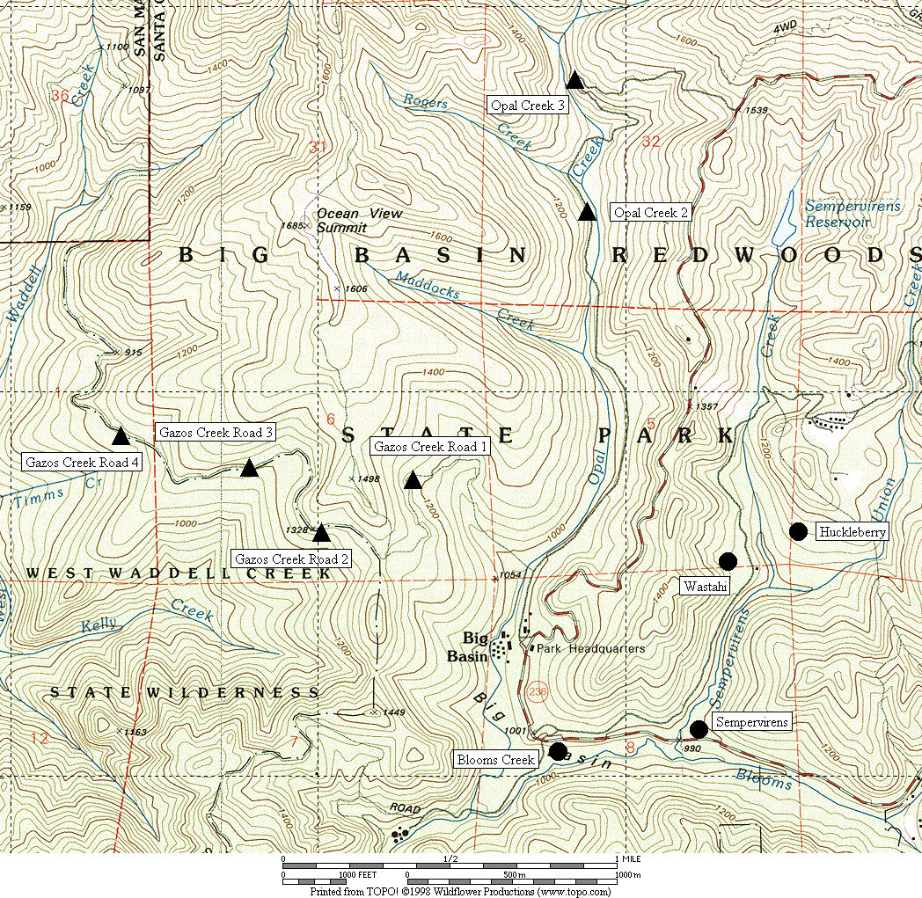

Figure 4. General location of corvid surveys area at Big Basin Redwoods State Park.
● treatment sites ▲ control sites

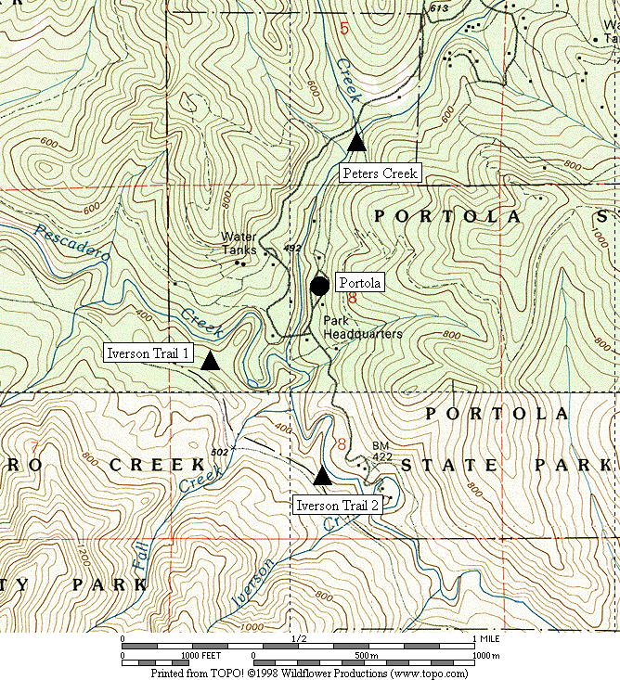

Figure 5. General location of corvid surveys area at Portola Redwoods State Park.
● treatment sites ▲ control sites

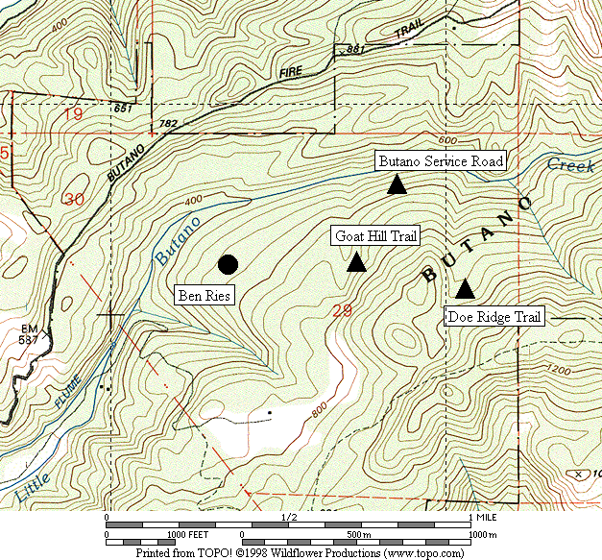

Figure 6. General location of corvid surveys area at Butano State Park.
● treatment sites ▲ control sites

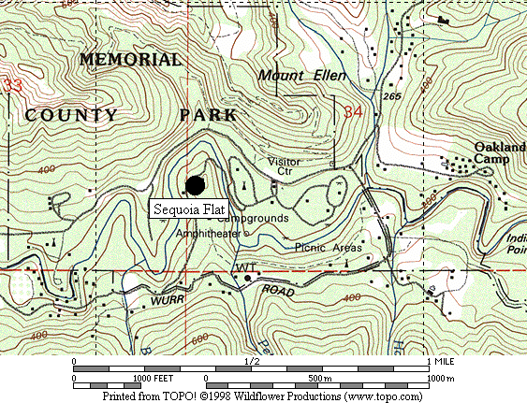

Figure 7. General location of corvid surveys area at San Mateo County Memorial Park.
● treatment site

Figure 8. Abundance of Steller’s Jay at all sites combined from 2002 to 2008.

A. Big Basin B. Portola

C. Butano D. Memorial

Figure 9. Abundance of Steller’s Jay in each park from 2003 to 2008.

Figure 10. Relative abundance of Steller’s Jays in treatment areas in each park from 2003-2008.

Figure 11. Comparison of seasonal increase in % juvenile Steller’s Jays in treatment and control areas, all parks combined (using average values from 2003-2008).

A. Treatment Areas B. Control Areas

Figure 12. Comparison of seasonal increase in number of adult and juvenile Steller’s Jays in treatment and control areas, all parks combined (using average values from 2003-2008).

A. Treament Areas B. Control Areas

Figure 13. Comparison of number of adult and juvenile Steller’s Jays in treatment and control areas, all parks combined, 2003-2008 (using adjusted raw maxima).

A. Big Basin B. Portola

C. Butano D. Memorial

Figure 14. Abundance of adult and juvenile Steller’s Jay in treatment areas of each park from 2003 to 2008 (using adjusted raw counts).

A. Big Basin B. Portola

C. Butano D. Memorial

Figure 15. Abundance of adult Steller’s Jay in June compared to the seasonal maximum in each park from 2003 to 2008 (using adjusted raw counts).
Figure 16a. Absolute number of adult Steller’s Jays in treatment areas of each park from 2003-2008 (using adjusted raw counts).

Figure 16b. Absolute number of juvenile Steller’s Jays in treatment areas of each park from 2003-2008 (using adjusted raw counts).

Figure 17. Abundance of Common Raven at all sites combined from 2002 to 2008.

A. Big Basin B. Portola
(Note: no ravens recorded in control
areas at Portola in 2005 or 2006)

C. Butano D. Memorial

Figure 18. Abundance of Common Raven in each park from 2003 to 2008.

Figure 19. Relative abundance of Common Raven in treatment areas in each park from 2003-2008.

Appendix 1. Raw numbers of Steller’s Jays and Common Ravens on each survey, 2003-2008.

STELLER’S JAY

Year |  | 03 |  |  |  | 04 |  |  |  | 05 |  |  |  | 06 |  |  |  | 07 |  |  |  | 08
Run # | 1 | 2 | 3 | 4 | 1 | 2 | 3 | 4 | 1 | 2 | 3 | 4 | 1 | 2 | 3 | 4 | 1 | 2 | 3 | 4 | 1 | 2 | 3 | 4
Big Basin
Blooms | 25 | 47 | 57 | 93 | 27 | 18 | 47 | 36 | 22 | 48 | 43 | 53 | 18 | 44 | 68 | 85 | 17 | 27 | 46 | 25 | 20 | 21 | 57 | 30
Sempervirens | 11 | 25 | 33 | 54 | 17 | 19 | 18 | 25 | 11 | 19 | 14 | 19 | 5 | 13 | 28 | 9 | 9 | 10 | 15 | 8 | 6 | 8 | 21 | 23
Huckleberry | 41 | 45 | 48 | 102 | 48 | 39 | 23 | 32 | 27 | 26 | 39 | 37 | 12 | 34 | 41 | 58 | 27 | 33 | 53 | 19 | 27 | 42 | 45 | 10
Wastahi | 10 | 2 | 4 | 23 | 4 | 10 | 15 | 16 | 2 | 5 | 4 | 6 | 2 | 8 | 7 | 5 | 4 | 3 | 9 | 7 | 3 | 2 | 2 | 0
Opal 2 | 3 | 3 | 2 | 1 | 0 | 2 | 1 | 3 | 1 | 1 | 0 | 2 | 0 | 2 | 1 | 2 | 5 | 2 | 4 | 0 | 0 | 2 | 2 | 1
Opal 3 | 4 | 0 | 2 | 0 | 1 | 4 | 2 | 2 | 0 | 2 | 0 | 0 | 0 | 0 | 0 | 0 | 2 | 2 | 2 | 2 | 2 | 2 | 2 | 1
Gazos 1 | 4 | 4 | 3 | 1 | 2 | 2 | 1 | 1 | 1 | 3 | 0 | 0 | 2 | 4 | 2 | 2 | 0 | 2 | 3 | 1 | 2 | 2 | 2 | 1
Gazos 2 | 0 | 2 | 2 | 1 | 1 | 1 | 0 | 1 | 3 | 0 | 0 | 0 | 0 | 1 | 1 | 2 | 1 | 0 | 1 | 0 | 1 | 0 | 2 | 0
Gazos 3 | 1 | 4 | 3 | 0 | 2 | 0 | 2 | 2 | 0 | 2 | 0 | 0 | 1 | 2 | 2 | 2 | 2 | 0 | 1 | 1 | 2 | 4 | 4 | 2
Gazos 4 | 3 | 2 | 2 | 3 | 1 | 1 | 0 | 0 | 0 | 1 | 0 | 1 | 0 | 2 | 1 | 1 | 4 | 1 | 4 | 1 | 2 | 2 | 1 | 0
Portola
Portola | 7 | 24 | 24 | 37 | 28 | 19 | 20 | 23 | 17 | 16 | 30 | 27 | 17 | 21 | 27 | 21 | 9 | 11 | 19 | 22 | 10 | 24 | 24 | 14
Peters | 3 | 4 | 3 | 3 | 1 | 2 | 0 | 3 | 2 | 0 | 1 | 5 | 1 | 2 | 3 | 2 | 3 | 3 | 0 | 1 | 2 | 2 | 3 | 2
Iverson 1 | 8 | 5 | 6 | 6 | 1 | 3 | 2 | 1 | 0 | 4 | 0 | 8 | 2 | 1 | 2 | 1 | 3 | 2 | 5 | 4 | 3 | 2 | 3 | 2
Iverson 2 | 3 | 2 | 5 | 2 | 0 | 2 | 3 | 2 | 1 | 0 | 0 | 1 | 3 | 2 | 3 | 1 | 2 | 3 | 3 | 4 | 3 | 5 | 2 | 2
Butano
Ben Ries | 22 | 32 | 35 | 45 | 18 | 34 | 40 | 46 | 11 | 16 | 43 | 20 | 3 | 15 | 22 | 29 | 3 | 4 | 4 | 6 | 4 | 4 | 5 | 6
Service | 4 | 8 | 3 | 4 | 2 | 2 | 5 | 4 | 2 | 2 | 4 | 0 | 4 | 8 | 4 | 6 | 1 | 3 | 0 | 1 | 2 | 4 | 3 | 4
Goat Hill | 4 | 3 | 2 | 3 | 4 | 2 | 2 | 2 | 2 | 4 | 1 | 3 | 1 | 5 | 3 | 3 | 1 | 2 | 2 | 0 | 1 | 7 | 1 | 1
Doe Ridge | 6 | 12 | 5 | 5 | 11 | 7 | 7 | 4 | 7 | 5 | 1 | 2 | 2 | 5 | 4 | 3 | 3 | 2 | 2 | 0 | 2 | 5 | 2 | 1
Memorial
Sequoia | 46 | 71 | 107 | 179 | 46 | 79 | 136 | 133 | 36 | 76 | 161 | 142 | 25 | 42 | 48 | 93 | 23 | 61 | 68 | 104 | 24 | 60 | 96 | 98

Appendix 1, continued.

COMMON RAVEN

Year |  | 03 |  |  |  | 04 |  |  |  | 05 |  |  |  | 06 |  |  |  | 07 |  |  |  | 08
Run # | 1 | 2 | 3 | 4 | 1 | 2 | 3 | 4 | 1 | 2 | 3 | 4 | 1 | 2 | 3 | 4 | 1 | 2 | 3 | 4 | 1 | 2 | 3 | 4
Big Basin
Blooms | 3 | 3 | 0 | 0 | 2 | 2 | 2 | 2 | 2 | 0 | 0 | 2 | 1 | 2 | 0 | 2 | 2 | 4 | 4 | 2 | 4 | 4 | 4 | 2
Sempervirens | 1 | 0 | 0 | 0 | 1 | 0 | 4 | 4 | 1 | 0 | 0 | 0 | 0 | 1 | 0 | 0 | 1 | 0 | 0 | 1 | 0 | 1 | 1 | 1
Huckleberry | 3 | 3 | 3 | 3 | 2 | 3 | 2 | 4 | 2 | 2 | 5 | 1 | 3 | 5 | 4 | 1 | 4 | 5 | 5 | 0 | 2 | 1 | 5 | 0
Wastahi | 0 | 0 | 0 | 0 | 1 | 1 | 1 | 1 | 1 | 3 | 2 | 0 | 0 | 1 | 1 | 0 | 2 | 0 | 4 | 1 | 0 | 0 | 0 | 2
Opal 2 | 0 | 0 | 1 | 0 | 1 | 0 | 1 | 1 | 0 | 0 | 0 | 0 | 0 | 0 | 0 | 0 | 0 | 0 | 0 | 1 | 0 | 0 | 0 | 0
Opal 3 | 0 | 3 | 0 | 0 | 0 | 0 | 0 | 0 | 0 | 0 | 0 | 0 | 2 | 0 | 0 | 1 | 2 | 1 | 4 | 0 | 0 | 0 | 1 | 0
Gazos 1 | 0 | 0 | 0 | 0 | 0 | 0 | 0 | 0 | 0 | 1 | 0 | 0 | 0 | 1 | 0 | 1 | 0 | 0 | 0 | 0 | 1 | 0 | 0 | 1
Gazos 2 | 0 | 0 | 0 | 0 | 0 | 0 | 0 | 0 | 0 | 0 | 0 | 0 | 0 | 0 | 0 | 0 | 0 | 0 | 0 | 0 | 0 | 0 | 0 | 0
Gazos 3 | 0 | 1 | 1 | 0 | 0 | 1 | 0 | 0 | 0 | 0 | 0 | 0 | 0 | 0 | 0 | 0 | 0 | 0 | 0 | 1 | 0 | 0 | 1 | 0
Gazos 4 | 0 | 0 | 0 | 0 | 0 | 0 | 0 | 0 | 0 | 0 | 0 | 0 | 0 | 0 | 0 | 0 | 0 | 0 | 0 | 0 | 0 | 0 | 0 | 0
Portola
Portola | 0 | 4 | 3 | 3 | 1 | 5 | 4 | 2 | 1 | 0 | 0 | 0 | 2 | 2 | 3 | 1 | 1 | 3 | 4 | 2 | 1 | 4 | 1 | 0
Peters | 0 | 1 | 0 | 0 | 0 | 0 | 0 | 0 | 0 | 0 | 0 | 0 | 0 | 0 | 0 | 0 | 0 | 0 | 0 | 0 | 0 | 0 | 0 | 0
Iverson 1 | 0 | 0 | 1 | 0 | 1 | 0 | 0 | 0 | 0 | 0 | 0 | 0 | 0 | 0 | 0 | 0 | 1 | 0 | 0 | 0 | 1 | 0 | 0 | 0
Iverson 2 | 0 | 0 | 0 | 0 | 0 | 0 | 0 | 0 | 0 | 0 | 0 | 0 | 0 | 0 | 0 | 0 | 1 | 1 | 0 | 0 | 0 | 0 | 0 | 0
Butano
Ben Ries | 1 | 0 | 0 | 1 | 2 | 1 | 6 | 7 | 1 | 0 | 0 | 0 | 2 | 2 | 1 | 2 | 1 | 2 | 5 | 4 | 0 | 0 | 0 | 2
Service | 1 | 1 | 0 | 1 | 0 | 0 | 0 | 0 | 0 | 0 | 0 | 0 | 0 | 0 | 0 | 0 | 0 | 0 | 0 | 0 | 0 | 0 | 0 | 0
Goat Hill | 0 | 0 | 0 | 0 | 0 | 0 | 0 | 0 | 0 | 0 | 0 | 0 | 1 | 0 | 0 | 0 | 0 | 0 | 0 | 0 | 0 | 0 | 0 | 0
Doe Ridge | 0 | 0 | 0 | 0 | 1 | 1 | 0 | 0 | 0 | 1 | 0 | 0 | 0 | 0 | 0 | 0 | 0 | 0 | 0 | 1 | 0 | 0 | 0 | 0
Memorial
Sequoia | 2 | 3 | 4 | 5 | 7 | 5 | 7 | 5 | 5 | 5 | 9 | 2 | 2 | 3 | 0 | 0 | 7 | 4 | 5 | 7 | 3 | 6 | 1 | 4

Appendix 2. Adjusted numbers of adult and juvenile Steller’s Jays, 2003-2008.

2003 | Treatment Areas |  |  |  |  | Control Areas
Big Basin | Run 1 | Run 2 | Run 3 | Run 4 |  | Run 1 | Run 2 | Run 3 | Run 4
Adults | 87 | 108 | 120 | 152 |  | 15 | 15 | 14 | 5
Juveniles | 0 | 11 | 22 | 120 |  | 0 | 0 | 0 | 0
% Juveniles | 0.0% | 9.3% | 15.7% | 44.2% |  | 0.0% | 0.0% | 0.0% | 0.0%
Portola
Adults | 7 | 21 | 20 | 21 |  | 14 | 11 | 14 | 9
Juveniles | 0 | 3 | 4 | 16 |  | 0 | 0 | 0 | 2
% Juveniles | 0.0% | 13.0% | 18.2% | 43.3% |  | 0.0% | 0.0% | 0.0% | 14.3%
Butano
Adults | 22 | 27 | 30 | 40 |  | 14 | 23 | 10 | 10
Juveniles | 0 | 5 | 5 | 5 |  | 0 | 0 | 0 | 2
% Juveniles | 0.0% | 15.6% | 15.6% | 10.8% |  | 0.0% | 0.0% | 0.0% | 14.3%
Memorial
Adults | 46 | 65 | 88 | 128 |  | -- | -- | -- | --
Juveniles | 0 | 6 | 19 | 51 |  | -- | -- | -- | --
% Juveniles | 0.0% | 8.1% | 18.1% | 28.5% |  | -- | -- | -- | --
All Parks
Adults | 162 | 221 | 257 | 341 |  | 43 | 49 | 38 | 25
Juveniles | 0 | 25 | 51 | 192 |  | 0 | 0 | 0 | 3
% Juveniles | 0.0% | 10.1% | 16.7% | 36.1% |  | 0.0% | 0.0% | 0.0% | 11.7%
Appendix 2, continued.
2004 | Treatment Areas |  |  |  |  | Control Areas
Big Basin | Run 1 | Run 2 | Run 3 | Run 4 |  | Run 1 | Run 2 | Run 3 | Run 4
Adults | 96 | 79 | 82 | 81 |  | 7 | 8 | 6 | 9
Juveniles | 0 | 7 | 21 | 28 |  | 0 | 2 | 0 | 0
% Juveniles | 0.0% | 8.3% | 20.5% | 25.3% |  | 0.0% | 22.2% | 0.0% | 0.0%
Portola
Adults | 24 | 19 | 15 | 9 |  | 2 | 7 | 4 | 6
Juveniles | 4 | 0 | 5 | 14 |  | 0 | 0 | 1 | 0
% Juveniles | 14.3% | 0.0% | 25.0% | 58.8% |  | 0.0% | 0.0% | 20.0% | 0.0%
Butano
Adults | 18 | 32 | 30 | 36 |  | 17 | 9 | 9 | 8
Juveniles | 0 | 2 | 10 | 10 |  | 0 | 2 | 5 | 2
% Juveniles | 0.0% | 6.5% | 25.8% | 22.2% |  | 0.0% | 18.2% | 35.7% | 22.2%
Memorial
Adults | 43 | 71 | 95 | 48 |  | -- | -- | -- | --
Juveniles | 3 | 8 | 41 | 85 |  | -- | -- | -- | --
% Juveniles | 7.3% | 10.6% | 30.4% | 64.2% |  | -- | -- | -- | --
All Parks
Adults | 181 | 200 | 221 | 174 |  | 26 | 24 | 19 | 23
Juveniles | 7 | 18 | 78 | 137 |  | 0 | 4 | 6 | 2
% Juveniles | 3.9% | 8.1% | 26.0% | 43.9% |  | 0.0% | 15.1% | 24.0% | 8.9%

Appendix 2, continued.

2005 | Treatment Areas |  |  |  |  | Control Areas
Big Basin | Run 1 | Run 2 | Run 3 | Run 4 |  | Run 1 | Run 2 | Run 3 | Run 4
Adults | 62 | 83 | 82 | 30 |  | 5 | 9 | 0 | 3
Juveniles | 0 | 15 | 18 | 85 |  | 0 | 0 | 0 | 0
% Juveniles | 0.0% | 15.2% | 18.0% | 73.5% |  | 0.0% | 0.0% | #DIV/0! | 0.0%
Portola
Adults | 17 | 13 | 10 | 4 |  | 3 | 4 | 1 | 9
Juveniles | 0 | 3 | 20 | 23 |  | 0 | 0 | 0 | 5
% Juveniles | 0.0% | 18.8% | 68.0% | 84.2% |  | 0.0% | 0.0% | 0.0% | 36.4%
Butano
Adults | 11 | 16 | 28 | 10 |  | 11 | 11 | 6 | 5
Juveniles | 0 | 0 | 15 | 10 |  | 0 | 0 | 0 | 0
% Juveniles | 0.0% | 0.0% | 34.1% | 50.0% |  | 0.0% | 0.0% | 0.0% | 0.0%
Memorial
Adults | 36 | 72 | 109 | 28 |  | -- | -- | -- | --
Juveniles | 0 | 4 | 52 | 114 |  | -- | -- | -- | --
% Juveniles | 0.0% | 5.9% | 32.4% | 80.6% |  | -- | -- | -- | --
All Parks
Adults | 126 | 184 | 229 | 72 |  | 19 | 24 | 7 | 17
Juveniles | 0 | 22 | 105 | 232 |  | 0 | 0 | 0 | 5
% Juveniles | 0.0% | 10.9% | 31.5% | 76.2% |  | 0.0% | 0.0% | 0.0% | 23.1%
Appendix 2, continued.
2006 | Treatment Areas |  |  |  |  | Control Areas
Big Basin | Run 1 | Run 2 | Run 3 | Run 4 |  | Run 1 | Run 2 | Run 3 | Run 4
Adults | 37 | 91 | 102 | 34 |  | 3 | 11 | 6 | 7
Juveniles | 0 | 8 | 42 | 123 |  | 0 | 0 | 0 | 0
% Juveniles | 0.0% | 7.7% | 29.0% | 78.6% |  | 0.0% | 0.0% | 0.0% | 0.0%
Portola
Adults | 17 | 18 | 22 | 4 |  | 6 | 5 | 8 | 4
Juveniles | 0 | 3 | 5 | 18 |  | 0 | 0 | 0 | 0
% Juveniles | 0.0% | 15.0% | 19.2% | 83.3% |  | 0.0% | 0.0% | 0.0% | 0.0%
Butano
Adults | 3 | 14 | 21 | 15 |  | 7 | 17 | 11 | 8
Juveniles | 0 | 1 | 1 | 15 |  | 0 | 1 | 0 | 0
% Juveniles | 0.0% | 7.7% | 5.0% | 50.0% |  | 0.0% | 3.7% | 0.0% | 0.0%
Memorial
Adults | 25 | 35 | 42 | 18 |  | -- | -- | -- | --
Juveniles | 0 | 7 | 6 | 75 |  | -- | -- | -- | --
% Juveniles | 0.0% | 17.8% | 11.6% | 80.5% |  | -- | -- | -- | --
All Parks
Adults | 82 | 158 | 187 | 70 |  | 16 | 33 | 25 | 19
Juveniles | 0 | 19 | 54 | 230 |  | 0 | 1 | 0 | 0
% Juveniles | 0.0% | 11.0% | 22.3% | 76.8% |  | 0.0% | 1.9% | 0.0% | 0.0%
Appendix 2, continued.
2007 | Treatment Areas |  |  |  |  | Control Areas
Big Basin | Run 1 | Run 2 | Run 3 | Run 4 |  | Run 1 | Run 2 | Run 3 | Run 4
Adults | 57 | 64 | 74 | 30 |  | 14 | 7 | 10 | 4
Juveniles | 0 | 9 | 49 | 29 |  | 0 | 0 | 5 | 1
% Juveniles | 0.0% | 12.5% | 40.2% | 49.0% |  | 0.0% | 0.0% | 35.7% | 25.0%
Portola
Adults | 9 | 10 | 12 | 8 |  | 8 | 8 | 6 | 7
Juveniles | 0 | 1 | 7 | 14 |  | 0 | 0 | 2 | 2
% Juveniles | 0.0% | 10.0% | 38.9% | 61.9% |  | 0.0% | 0.0% | 25.0% | 22.2%
Butano
Adults | 3 | 4 | 4 | 5 |  | 5 | 7 | 4 | 1
Juveniles | 0 | 0 | 0 | 1 |  | 0 | 0 | 0 | 0
% Juveniles | 0.0% | 0.0% | 0.0% | 20.0% |  | 0.0% | 0.0% | 0.0% | 0.0%
Memorial
Adults | 23 | 52 | 33 | 16 |  | -- | -- | -- | --
Juveniles | 0 | 9 | 35 | 88 |  | -- | -- | -- | --
% Juveniles | 0.0% | 15.1% | 50.8% | 84.2% |  | -- | -- | -- | --
All Parks
Adults | 92 | 130 | 123 | 60 |  | 27 | 22 | 20 | 12
Juveniles | 0 | 19 | 91 | 131 |  | 0 | 0 | 7 | 3
% Juveniles | 0.0% | 13.0% | 42.7% | 68.8% |  | 0.0% | 0.0% | 27.2% | 21.7%

Appendix 2, continued.

2008 | Treatment Areas |  |  |  |  | Control Areas
Big Basin | Run 1 | Run 2 | Run 3 | Run 4 |  | Run 1 | Run 2 | Run 3 | Run 4
Adults | 53 | 43 | 44 | 15 |  | 9 | 10 | 11 | 4
Juveniles | 3 | 30 | 81 | 48 |  | 0 | 2 | 2 | 0
% Juveniles | 5.4% | 41.1% | 64.8% | 76.2% |  | 0.0% | 16.7% | 15.4% | 0.0%
Portola
Adults | 10 | 14 | 9 | 4 |  | 6 | 9 | 8 | 5
Juveniles | 0 | 10 | 15 | 10 |  | 2 | 0 | 0 | 1
% Juveniles | 0.0% | 41.7% | 62.5% | 71.4% |  | 25.0% | 0.0% | 0.0% | 16.7%
Butano
Adults | 4 | 4 | 2 | 3 |  | 5 | 11 | 6 | 6
Juveniles | 0 | 0 | 3 | 3 |  | 0 | 5 | 0 | 0
% Juveniles | 0.0% | 0.0% | 60.0% | 50.0% |  | 0.0% | 31.3% | 0.0% | 0.0%
Memorial
Adults | 24 | 31 | 39 | 15 |  | -- | -- | -- | --
Juveniles | 0 | 29 | 57 | 83 |  | -- | -- | -- | --
% Juveniles | 0.0% | 48.3% | 59.4% | 84.7% |  | -- | -- | -- | --
All
Adults | 91 | 92 | 94 | 37 |  | 20 | 30 | 25 | 15
Juveniles | 3 | 69 | 156 | 144 |  | 2 | 7 | 2 | 1
% Juveniles | 3.2% | 42.9% | 62.4% | 79.6% |  | 9.1% | 18.9% | 7.4% | 6.3%

